Using the NewPing library with an Ultrasonic sensor

1. First you will need to get the NewPing library as a zip file. Place it on your desktop so you can find it easily.
2. Wire up your sensor to the Arduino as such:

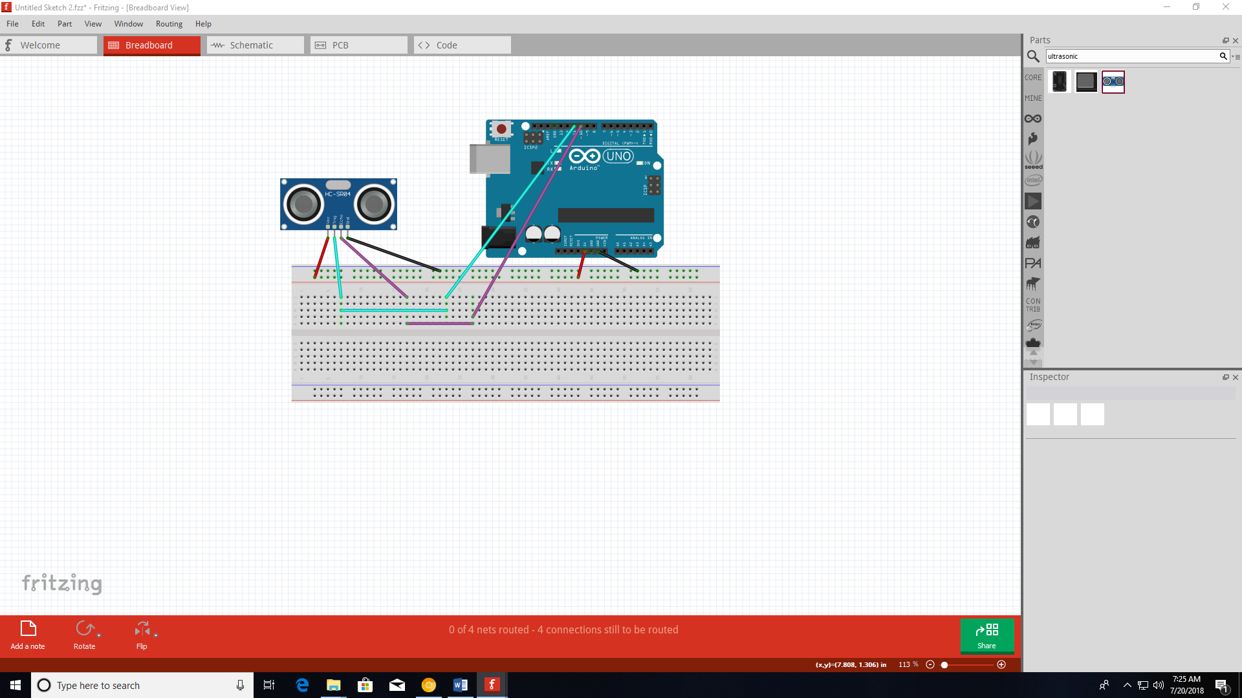

1. Start the Arduino IDE

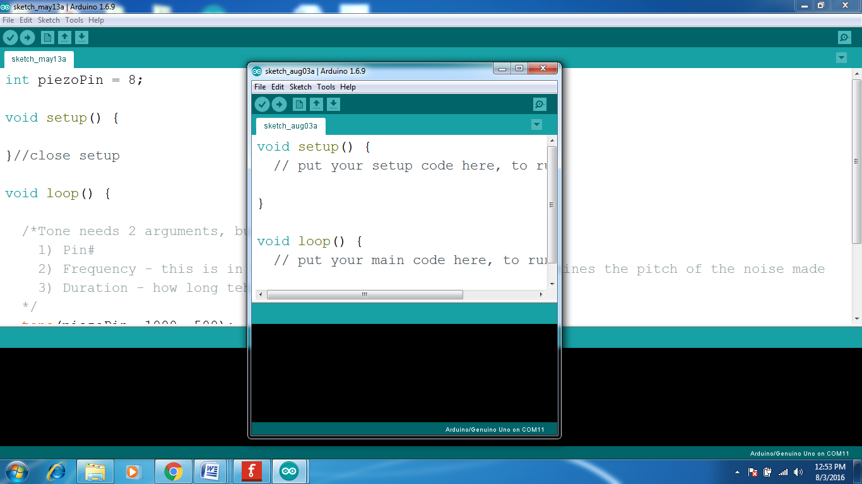

1. Add the NewPing library by going to the Sketch menu and selecting Add .ZIP Library…

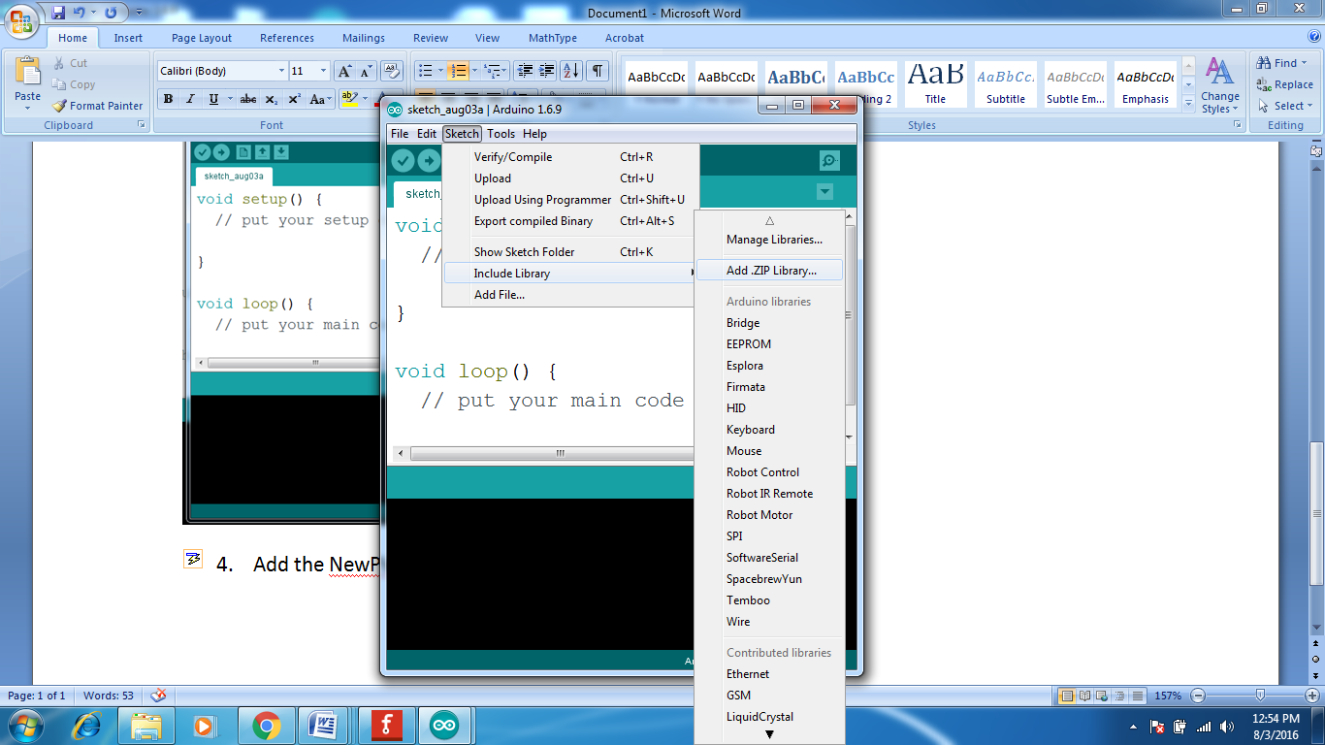

1. Navigate to the Desktop and select NewPing.zip
2. After the NewPing Library is installed, Select it from the Sketch Include Library menu.

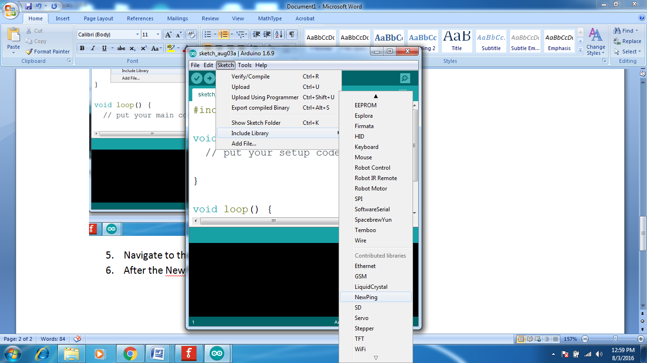

1. When you select it, it will automatically add the following line to your sketch.

#include <NewPing.h>

1. Here is a short demo program that you can run.

#include <NewPing.h>

#define TRIGGER_PIN 12 // Arduino pin tied to trigger pin on the ultrasonic sensor.

#define ECHO_PIN 11 // Arduino pin tied to echo pin on the ultrasonic sensor.

#define MAX_DISTANCE 200 // Maximum distance we want to ping for (in centimeters).

// Maximum sensor distance is rated at 400-500cm.

// NewPing setup of pins and maximum distance.

NewPing sonar(TRIGGER_PIN, ECHO_PIN, MAX_DISTANCE);

void setup() {

Serial.begin(115200); // Open serial monitor at 115200 baud to see ping results.

}

void loop() {

// Wait 50ms between pings (about 20 pings/sec).

//29ms should be the shortest delay between pings.

delay(50);

Serial.print("Ping: ");

// Send ping, get distance in inches and print result (0 = outside set distance range)

Serial.print(sonar.ping_in());

Serial.println(" inches");

delay(1000);

}

1. You can monitor the distance reported by opening the Serial Monitor and make sure your baud rate to 115200.

